Name : Hamza Tariq

Roll No : i21-0707

Section : Y

COAL HOMEWORK

CARRY FLAG:

.model small

.stack 100h

.data

var db 255

.code

mov ax, @data

mov ds, ax

mov al, var

add al,2

mov ah,4ch

int 21h

end

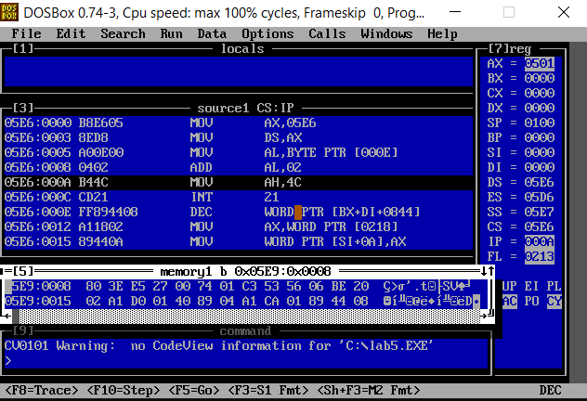

OVERFLOW FLAG:

.model small

.stack 100h

.data

var db +127

.code

mov ax, @data

mov ds, ax

mov al, var

add al,1

mov ah,4ch

int 21h

end

CARRY AND OVERFLOW FLAG:

.model small

.stack 100h

.data

var1 dw 11001000b

var2 dw 11010010b

.code

mov ax, @data

mov ds, ax

mov ax, var1

mov cx,var2

add bx,cx

mov ah,4ch

int 21h

end

